Design and Verification of Half Adder and Half Subtractor
Aim
To design and verify basic one-bit arithmetic circuits using Verilog HDL.
Theory / Synopsis
A Half Adder adds two single-bit binary numbers, A and B, and produces a Sum and a Carry output. A Half Subtractor subtracts one single-bit binary number B from another A, producing a Difference and a Borrow output. Both circuits are purely combinational and form the basic building blocks of larger arithmetic units such as Full Adders and Full Subtractors.
Boolean Functions
Half Adder:
- Sum = A ⊕ B
- Carry = A . B
Half Subtractor:
- Difference = A ⊕ B
- Borrow = A' . B
Files to be Created
File name | Purpose
half_add_sub.v | Arithmetic-circuit RTL
half_add_sub_tb.v | Stimulus and VCD generation
Design / RTL Program
// gedit half_add_sub.v
module half_adder (
input wire A,
input wire B,
output wire Sum,
output wire Carry
);
assign Sum = A ^ B; // XOR
assign Carry = A & B; // AND
endmodule

module half_subtractor (
input wire A,
input wire B,
output wire Diff,
output wire Borrow
);
assign Diff = A ^ B; // XOR
assign Borrow = (~A) & B; // A' . B
endmodule
Testbench Program
// gedit tb3.v
module tb3;
reg A, B;
wire Sum, Carry;
wire Diff, Borrow;

// Instantiate the Half Adder
half_adder ha_uut (
.A(A),
.B(B),
.Sum(Sum),
.Carry(Carry)
);

// Instantiate the Half Subtractor
half_subtractor hs_uut (
.A(A),
.B(B),
.Diff(Diff),
.Borrow(Borrow)
);

initial begin
// ---- VCD dump setup ----
$dumpfile("half_add_sub.vcd"); // name of the VCD file to be generated
$dumpvars(0, tb3); // dump all signals in this testbench hierarchy

// ---- Apply all 4 input combinations ----
$monitor("Time=%0t A=%b B=%b | Sum=%b Carry=%b | Diff=%b Borrow=%b",
$time, A, B, Sum, Carry, Diff, Borrow);
A = 0; B = 0; #10;
A = 0; B = 1; #10;
A = 1; B = 0; #10;
A = 1; B = 1; #10;

#10 $finish;
end
endmodule
Truth Table
A | B | Sum (HA) | Carry (HA) | Diff (HS) | Borrow (HS)
0 | 0 | 0 | 0 | 0 | 0
0 | 1 | 1 | 0 | 1 | 1
1 | 0 | 1 | 0 | 1 | 0
1 | 1 | 0 | 1 | 0 | 0
Simulation Procedure
STEP 1 – Open Terminal
Open a terminal in the experiment folder.
STEP 2 – Load Synopsys Environment
source /synopsys/start.sh
STEP 3 – Compile Using VCS
vcs half_add_sub.v half_add_sub_tb.v -full64
If compilation is successful, VCS generates the simulation executable:
simv
STEP 4 – Run Simulation
./simv
The terminal displays the input combinations and corresponding outputs Sum, Carry, Diff, and Borrow.
A VCD waveform file is also generated:
half_add_sub.vcd
STEP 5 – Open DVE
dve -full64
Other option
dve -full64 &
A DVE environment will open.
DVE Waveform Verification
In DVE:
- Open the testbench hierarchy.
- Locate the signals:
  - A
  - B
  - Sum
  - Carry
  - Diff
  - Borrow
- Add the signals to the waveform window.
- Run/inspect the waveform.
- Verify that Sum = 1 whenever A and B are different (A⊕B), and Carry = 1 only when A=1 AND B=1.
- Verify that Diff = 1 whenever A and B are different (same XOR pattern as Sum), and Borrow = 1 only when A=0 AND B=1.
- Confirm that Carry and Borrow never both go high for the same input pair, since they represent different (AND vs A'B) conditions.
The waveform should agree with the truth table.
Expected Result
The Half Adder and Half Subtractor were realized using Verilog HDL:
- Sum = A⊕B, Carry = A.B
- Diff = A⊕B, Borrow = A'.B
The design was compiled and simulated using Synopsys VCS, and the functionality was verified using DVE waveform analysis, matching the expected truth table.
Output
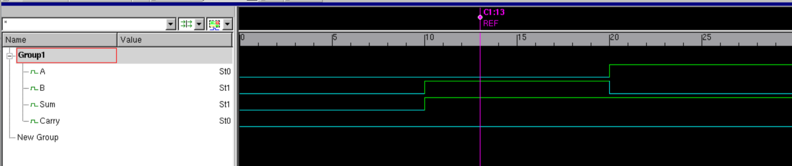

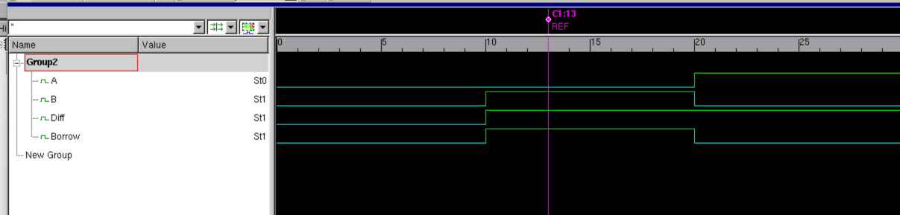
Viva-Voce Questions
- What is a Half Adder, and what are its limitations compared to a Full Adder?
- What is a Half Subtractor, and what does the Borrow output signify?
- Why is the Sum/Difference expression identical (A⊕B) for both circuits, while Carry and Borrow differ?
- What gate realizes the XOR function, and why is it central to both circuits?
- What is the purpose of a Verilog testbench?
- Why is a VCD file generated, and what does $dumpvars(0, tb) do?
- What is the purpose of ./simv?
- What is the difference between simulation and synthesis?
- How would you extend this design to a Full Adder/Full Subtractor?
Result
Thus, the Half Adder and Half Subtractor were designed, implemented using Verilog HDL, successfully simulated using Synopsys VCS, and verified using Synopsys DVE.

